دولة فلسطين  هيئة مكافحة الفساد  القدس – رام الله | 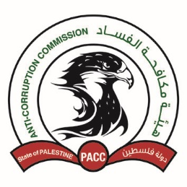 | State of Palestine  Anti-Corruption Commission  (PACC)  Jerusalem - Ramallah

An Invitation to Participate in Research Papers
The Palestinian Anti-Corruption Commission Cordially Invites to Actively Participate through Research Papers in

The International Conference Entitled
“Integrity and Governance for Sustainable Development”
During 9th -11th December, 2019
Ramallah
In accordance with the following topics:

First Topic: integrity, governance, and sustainable development in conformity with international principles.

The second Topic: the national legislations and policies enhancing integrity and governance for sustainable development.

The third Topic: Experiences and success stories in integrity and governance that enhance sustainable development.

The Fourth Topic: the Palestinian efforts in achieving the sustainable development indicators; rights and obligations.

Submitting the proposal of participation in research papers is until September 30, 2019. In the condition of accepting the proposals, the full research paper shall be presented before October 31, 2019.
Please visit the following website to fill in the form:
WWW.pacc.pna.ps/events/
To answer any inquiry please sends an email on the following email address: confe@pacc.pna.ps,
Or contact Mr Iyad Hamdan on: 0562777012

