Public Service Dimensions: Administrative Procedures and Public Service Delivery

In 2017 there was overall improvement compared to 2016 in the two dimensions that focus on public services: ‘Public Administrative Procedures’ and ‘Public Service Delivery.’ Citizens also reported more positive views and experiences related to corruption, which often has a direct impact on the performance of public service providers.
An important area of progress in 2017 was a remarkable closing of the gender gap in land use titling: in 2016 18% fewer women in rural areas reported having their names on land use certificates compared to men, but in 2017 the difference fell by half to 9%.
Another notable trend was the continued increase in the number of citizens with health insurance: the rate rose from 74% in 2016 to 81% in 2017. Further analysis shows that the strongest gains were made in rural population groups. In 2014, only 60% of rural residents had health insurance compared to 69% for urban residents, but the gap narrowed in 2017 to less than 4%.
Geographically, provinces in the Mekong Delta and the Southeast continued to be the best performers in the areas of administrative procedures and public service delivery.
Trends in Local Government Performance in First Two Years (2016-2017) of the 2016-2021 Government Term at the Indicator Level
By comparing the results for indicators in 2017 with 2016, the findings reveal key areas of progress, as well as setbacks, in the first two years of the current government office.
Dimension 5: Public Administrative Procedures. This dimension attempts to measure the quality of public administrative services in areas important to citizens. This includes public certification services as well as application procedures for construction permits, land use rights certificates, and personal documents. In particular, this dimension looks at how professional and responsive the administrative services provided are.
As mentioned above, the 2017 results show a rapid closing of the gender gap in land use titling. This trend reflects the effectiveness of actions taken to improve gender equity in land titling, an area of significant progress compared to 2016. Nonetheless, more efforts should be made to encourage women to co-sign their household land rights certificates to further reduce the gap.
The results of the 2017 survey also show there was a significant increase in total reported quality of services for construction permits in 2017 compared to the year before – with the aggregate score rising from 3.55 points in 2016 to 3.78 points in 2017 on a scale of 0-4 points. There was also a significant increase in applicants accessing one-stop windows for services related to land use rights certificates (up from 79% in 2016 to 86% in 2017), as well as a small increase in total quality of administrative services at the commune level (up from 3.34 points in 2016 to 3.44 points in 2017).
In other areas the results show some setbacks, with a slight decrease in total quality of administrative services for land use rights certificates (from 2.64 points in 2016 to 2.55 points in 2017 on a scale of 0-4 points). In addition, overall user satisfaction with administrative services for land use rights certificates fell below 4 points on the 0-5 point scale, lower than the level for construction permits and personal procedures.

Dimension 6: Public Service Delivery. This dimension looks at four public services: health care, primary education, basic infrastructure, and residential law and order. Similar to previous PAPI surveys, citizens were asked about their direct experience with the accessibility, quality and availability of these services in 2017.
Changes in this dimension have been gradual, though overall, there was a slight increase in the total quality of public primary schools and an insignificant decrease in the total quality of district public hospitals in all provinces over the two years of 2016 and 2017. However, both indicators show a large gap between the current status of provinces in these areas and expected maximum scores, implying that both sectors need to do more to satisfy citizens. Interestingly, this is the only dimension where gender and ethnicity did not matter greatly.
Provincial Performance in Public Service Delivery by Quartiles, 2017
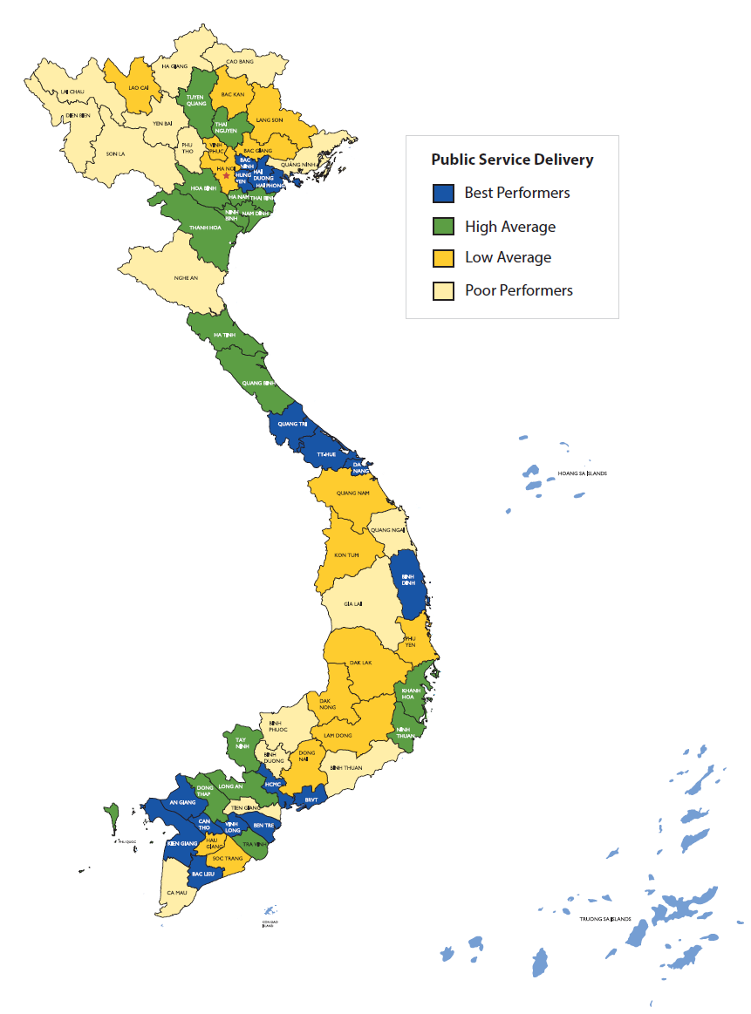
Corruption and Public Services. PAPI aims to understand the relationship between corruption, nepotism and public service delivery. The survey includes several questions related to corruption, including one about experiences with and perceptions of petty corruption, particularly bribes for public services and administrative procedures, and another about nepotism in public sector hiring.
The results show that across nearly all indicators, citizens believed there were lower levels of corruption in 2017; citizens were less likely to observe corruption in the public sector, in public service delivery, and in hiring for government positions. The one area that did not see as much improvement was citizen’s perception that local governments were willing to fight corruption, suggesting that while corruption in local governments is seen as less of a problem, local governments themselves are not significantly more likely to root out corruption proactively. One possible explanation is that the perceptions of reduced corruption are more related to efforts at the central level in dealing with high-profile corruption cases rather than to those of local-level governments in controlling everyday corruption. However, future surveys will need to assess this more carefully.

***

The Provincial Governance and Public Administration Performance Index (PAPI) is a policy monitoring tool that assesses citizen experiences and satisfaction with government performance at the national and sub-national levels in governance, public administration and public service delivery. Since its pilot in 2009, PAPI has directly interviewed 103,059 Vietnamese citizens nationwide.
PAPI measures six dimensions: participation at local levels, transparency, vertical accountability, control of corruption, public administrative procedures and public service delivery. The survey has been implemented nationwide each year since 2011. For the 2017 PAPI Report, 14,097 randomly selected citizens were surveyed.
PAPI is a collaboration between the Centre for Community Support and Development Studies (CECODES), the Centre for Research and Training of the Viet Nam Fatherland Front (VFF-CRT), the Real-Time Analytics and the United Nations Development Programme (UNDP).
Funding for PAPI has been generously provided by the Swiss Agency for Cooperation and Development (SDC) for 2011-2017; by the Department of Foreign Affairs and Trade (DFAT) of Australia for 2018-2021; by the Embassy of Ireland for 2018; and by the United Nations and UNDP in Viet Nam since 2009.
The full 2017 PAPI Report and more in-depth analysis can be found at: www.papi.org.vn.

